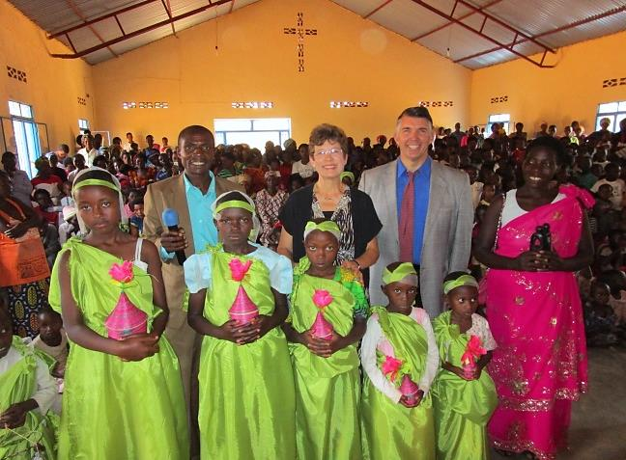
December 2015

“On coming to the house, they saw the child with his mother Mary, and they bowed down and worshiped him. Then they opened their treasures and presented him with gifts of gold, and of incense, and of myrrh.” Matthew 2:11

Dear Friends in Christ ~

Many wishes for a blessed Christmas and a Happy New Year from Patrick and Jeanne and the children of Rwanda!

Another Christmas is quickly approaching and with it the visit of family and friends and the opening of gifts. The greatest gift, however, is the gift of salvation through our risen Lord and Savior, Jesus Christ!

We want to thank you personally for your support and prayers which have helped us bring the Good News of Jesus Christ and His free gift of eternal life to so many children here in Rwanda.

To date, nineteen brick buildings have been completed to serve as children’s churches. This means that these children now have a place to call their own. They are free to worship the Lord and learn to grow in Him without fear of being chased away so that others can use the facility. They are also sheltered against the hot African sun as well as the intense wind and rain during the rainy seasons. Nineteen children’s churches are rejoicing over the wonderful and much needed gift of a building.

But what about the 100+ other children’s churches that still meet under the conditions that we have described above? Who will provide for them? For $6500 we can build an entire beautiful brick building that will be a church to over 300 children every Sunday and will be used during the week as so much more to bless the children of that village.

You can make a difference in the lives of the children of Rwanda; your church as well as your children’s church can make a lasting impact on a village by providing a place for the children to worship the Lord.

What gifts are you giving this Christmas? Are they temporary ones that wear out and are eventually thrown away or are they lasting gifts? The children are waiting….

With love and appreciation,

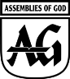
Patrick & Jeanne
Our A/G Giving account: 259067-7
E-mail us at: patrick.collins@agmd.org
Visit our Website: www.collinscall.Yolasite.com
To give directly to building children’s churches, Project 4616, Class 68:
http://s1.ag.org/project4616

